## Current Activities

The site remains closed, but curators have been able to access the museum by special request for a few essential tasks.

We are now able to reveal that the loan of our 080 card sorter is for Bletchley Park’s new WW2 exhibition to be opened next year. The machine still needs a new glass top cover to be made and a same size piece of plywood to put in its place instead during shipment.

In addition, our colleagues in Böblingen are making some audio recordings of working unit record machines. They have already sent a recording of their sorter, which will be used in the audio guide to the exhibition.

The new photo archive section referenced last time has been added to the museum website under 'photographs' - a large personal collection of IBM hardware photographs collected by Peter S over the years. <http://igonta.net/hursley/IBM%20Hardware/>

Further progress on the Extreme Blue project has been made with the acquisition of 3 iPads borrowed from another laboratory project. The prototype app is ready and is being tidied up. Curators have prepared some initial inputs for the app.

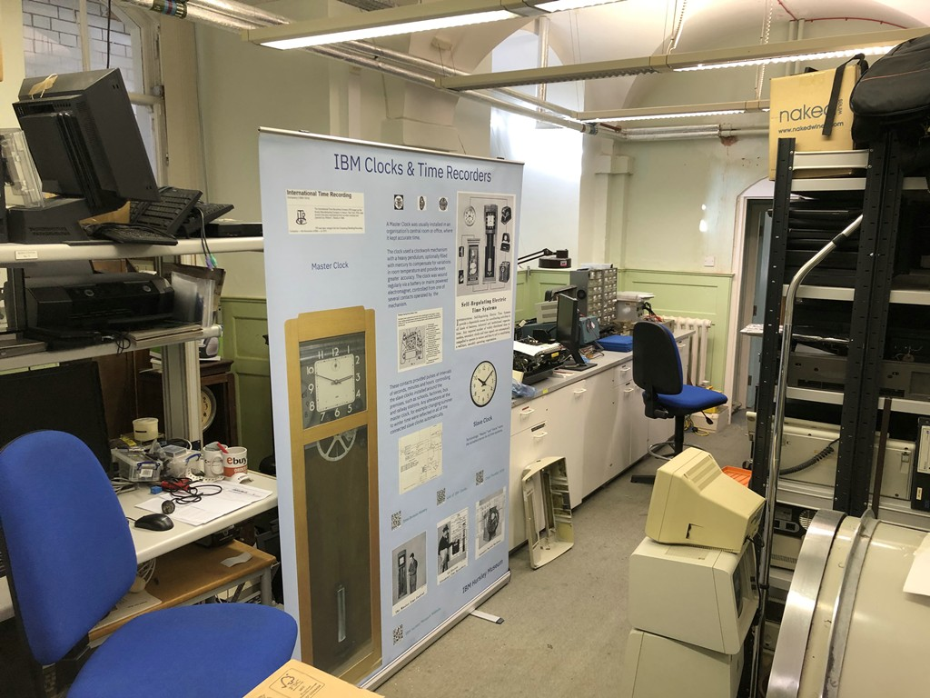Thanks to the agreement by the committee at the last meeting for a small grant, we have now had the clock banner produced. An actual clock will stand in front of the large clock image when we put it out on display.

